Zheen H. Suseyi

12/08/2022

CS 255

SNHU

# CS 255 System Design Document Template

## UML Diagrams

### UML Use Case Diagram

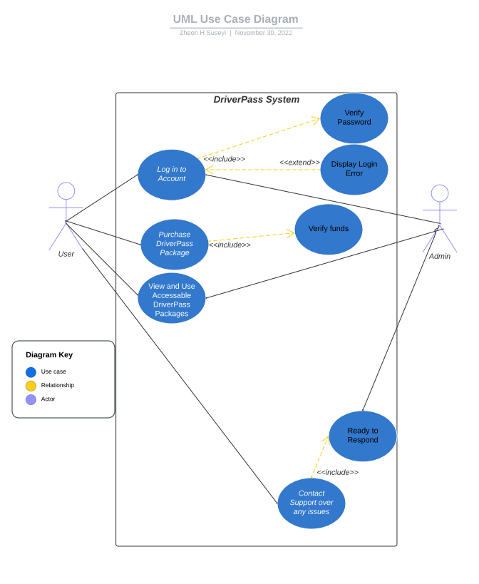

### UML Activity Diagrams

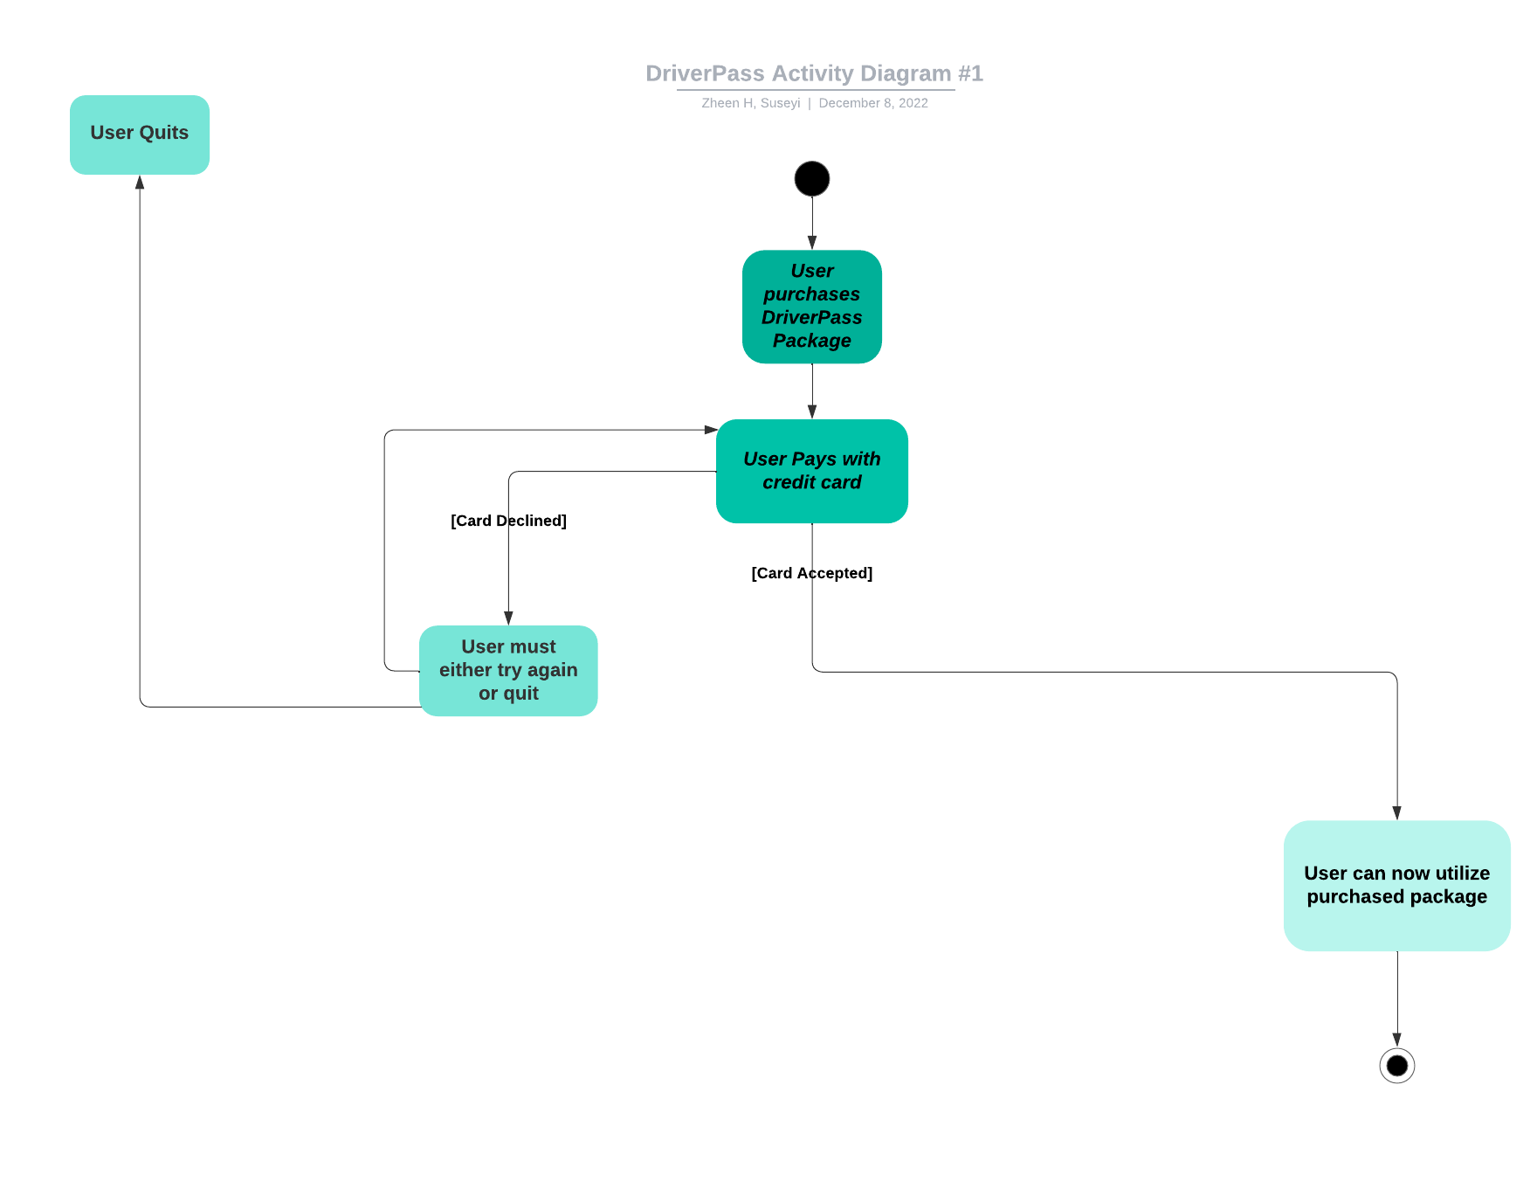

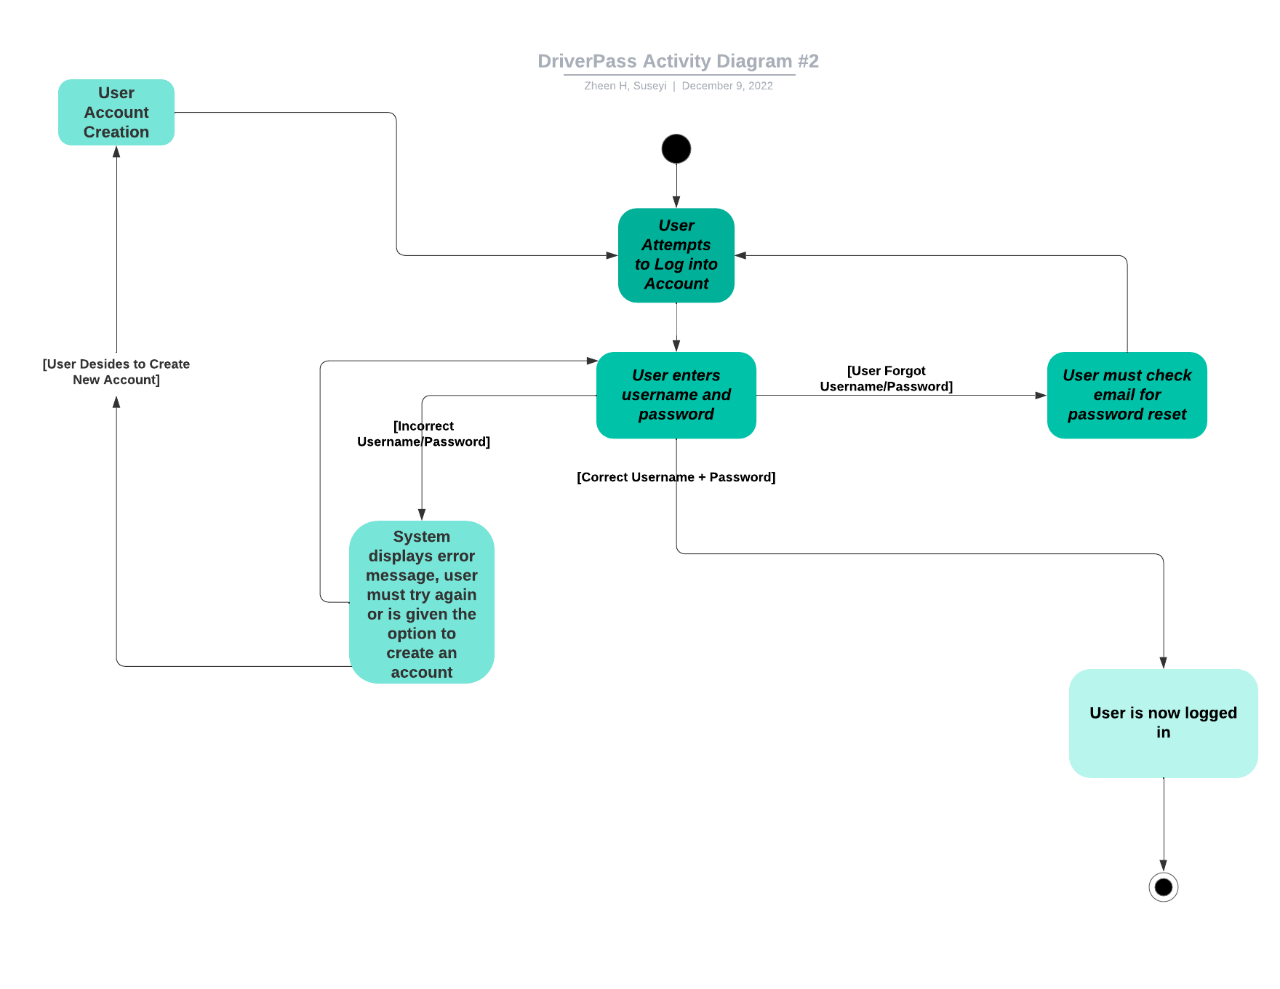

### UML Sequence Diagram

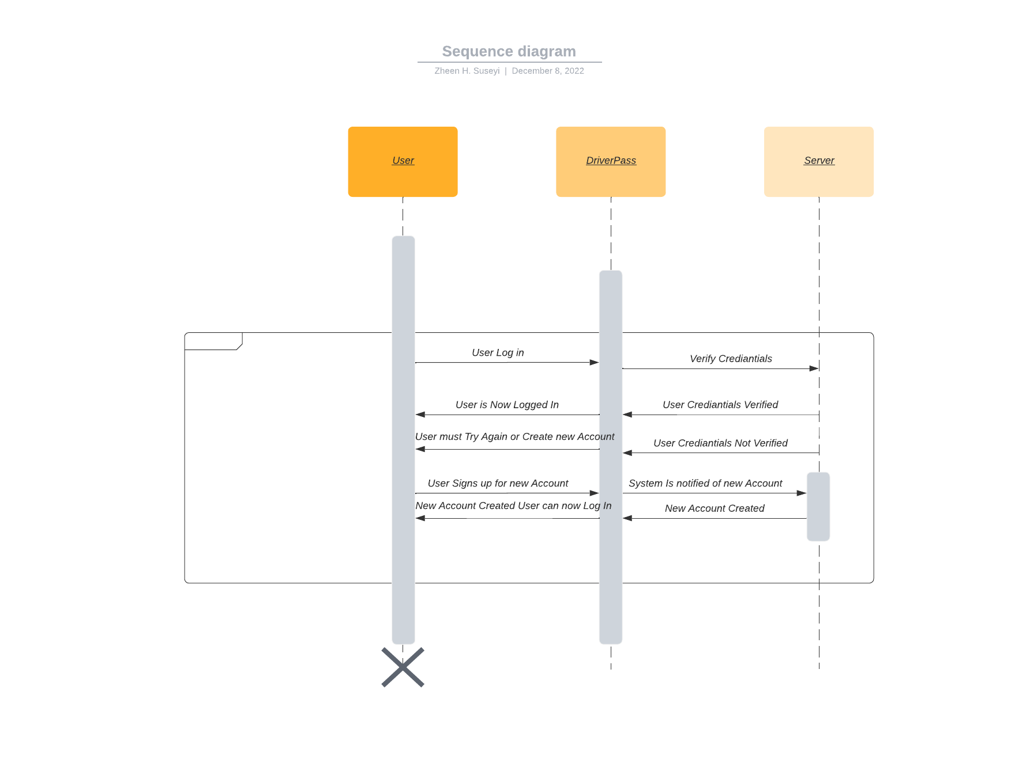

### UML Class Diagram

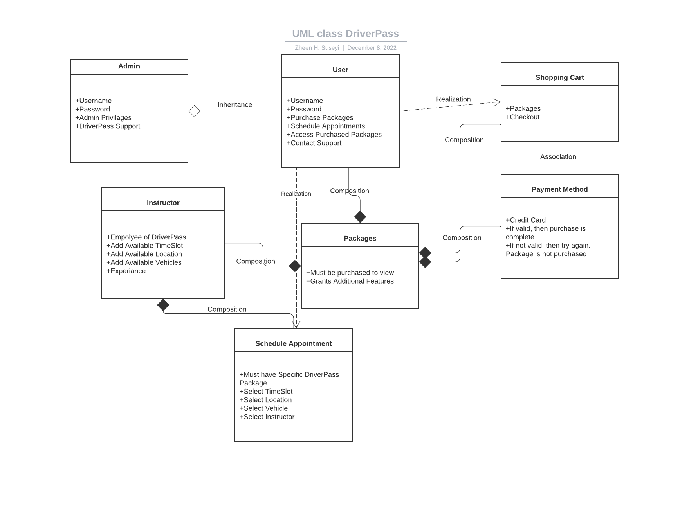

## Technical Requirements

The required hardware needed for DriverPass to function is first and foremost a database in order to store important data like packages, user details, and much more. The cloud can be used to store data because it is extremely secure and easy to set-up so I think utilizing the cloud is the play here. The software needed would be a website and database builder which would most likely be in Java so an IDE like Eclipse would be needed. A working Computer with proper internet would be needed for each developer and admin for DriverPass and then once the website is up, there will need to be some permanent developers for maintenance so that changes can be made if needed.